Here are some guidelines for the conversion jigs (AR Universal as well as AR mini).

First of all, if your receiver is brand new and has never been populated before, chances are that there is a ‘wad’ of anodizing in the safety hole. To clear it out prior to assembling the jig, ream by hand the holes out with a 3/8” drill bit.

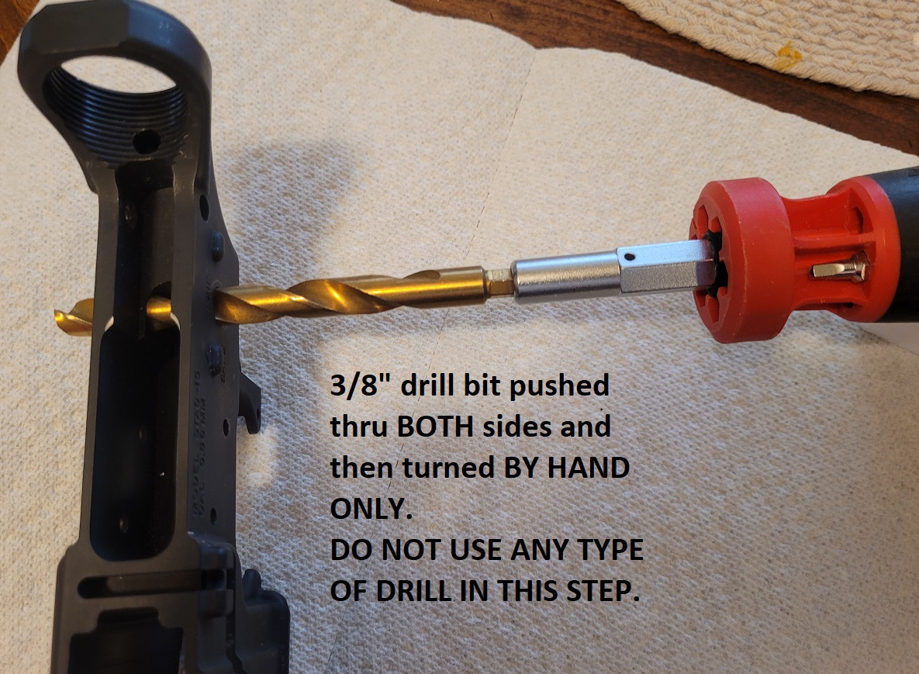

Blueprint for the after-anodized safety hole is .376”, my alignment dowel pins are .375” so there should never be any binding where you have to force the sideplates onto your receiver.

Then, if you have one, measure the top of the safety hole to the top plane of your AR receiver. It should be around .535” as shown below:
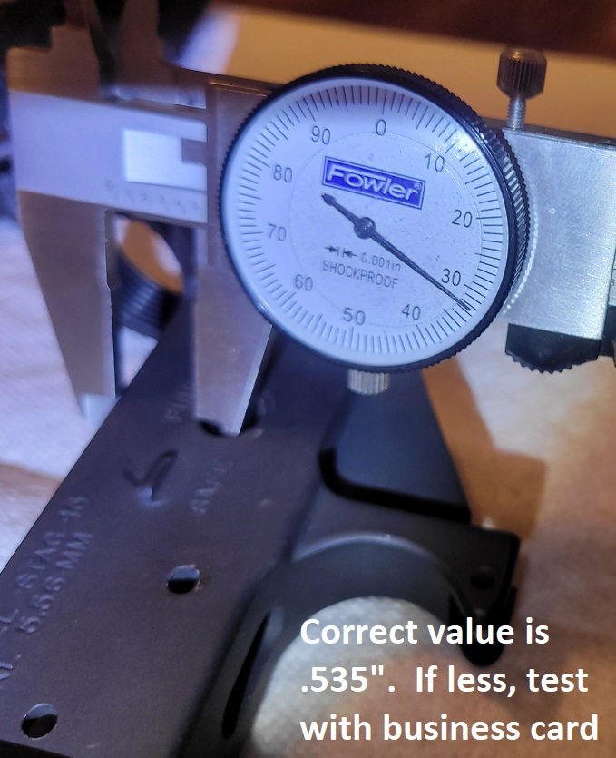

If it turns out to be less than .535”, your jig can ‘teeter totter’ (a back and forth pivoting around the safety holes). My jig is designed to show you exact height using only the sideplates. When the 2 sideplates are installed, they should be flush on the upper surface of the lower receiver as pictured below:
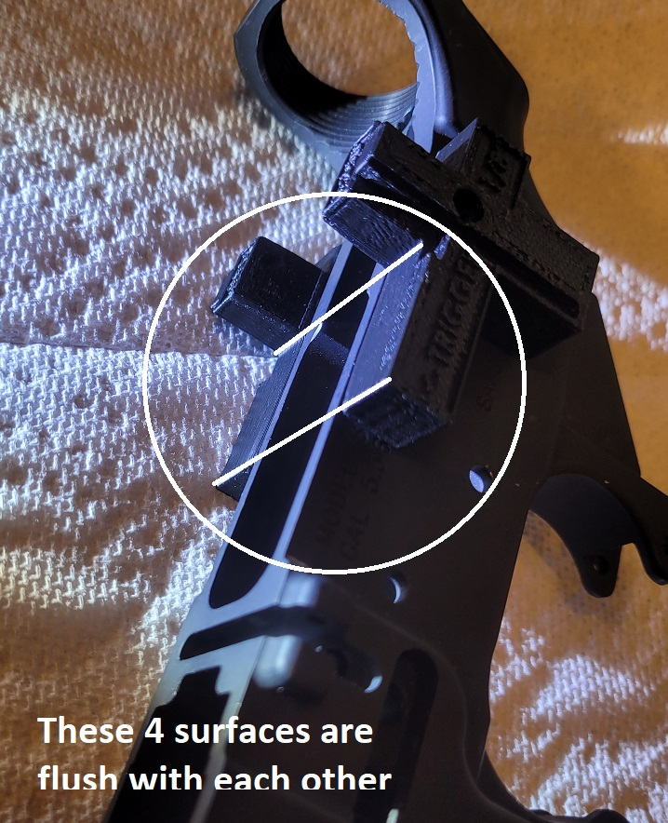

Next put the top plate on and it should sit flush on all 4 surfaces shown above. Picture below shows this relationship of fitment.
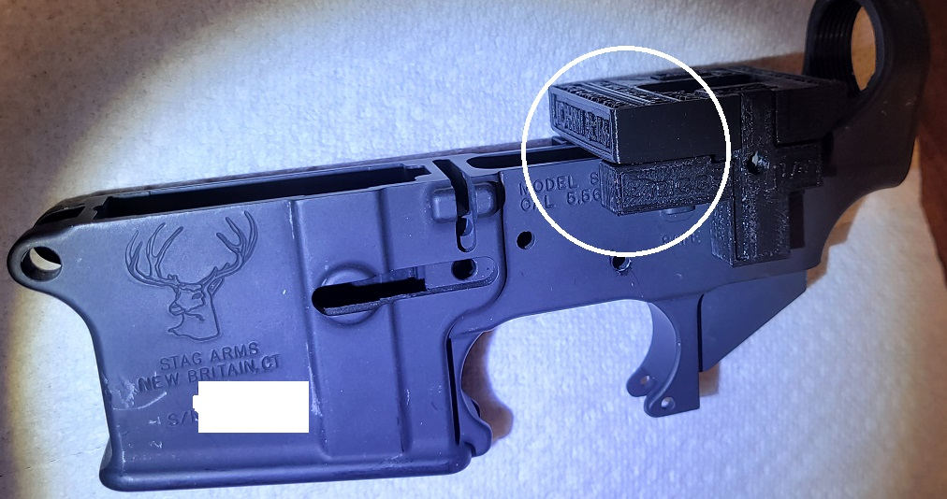

If you have some “teeter totter”, take a business card and fold it lengthwise as shown below:

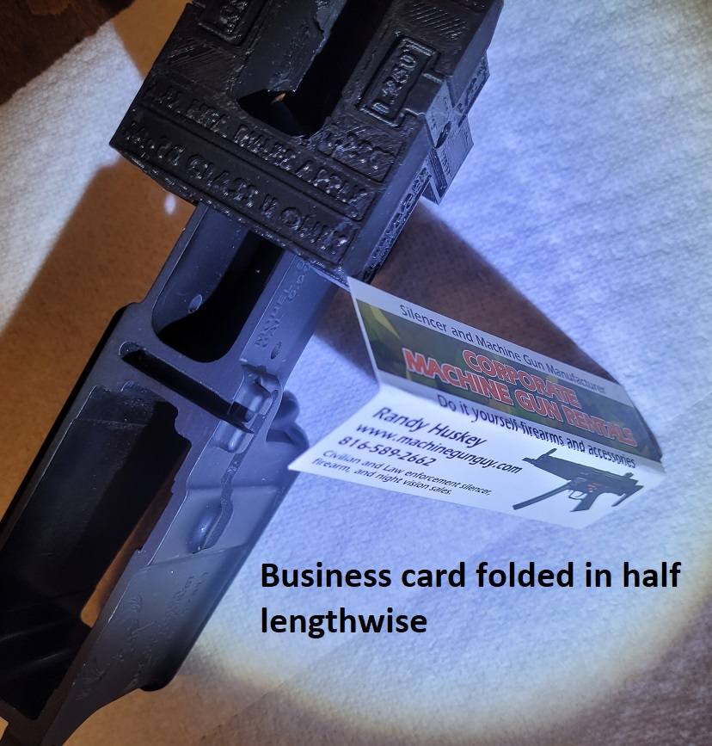

Then slide the folded card lengthwise under the entire top plate. If the teeter totter stops, you are still good to go:

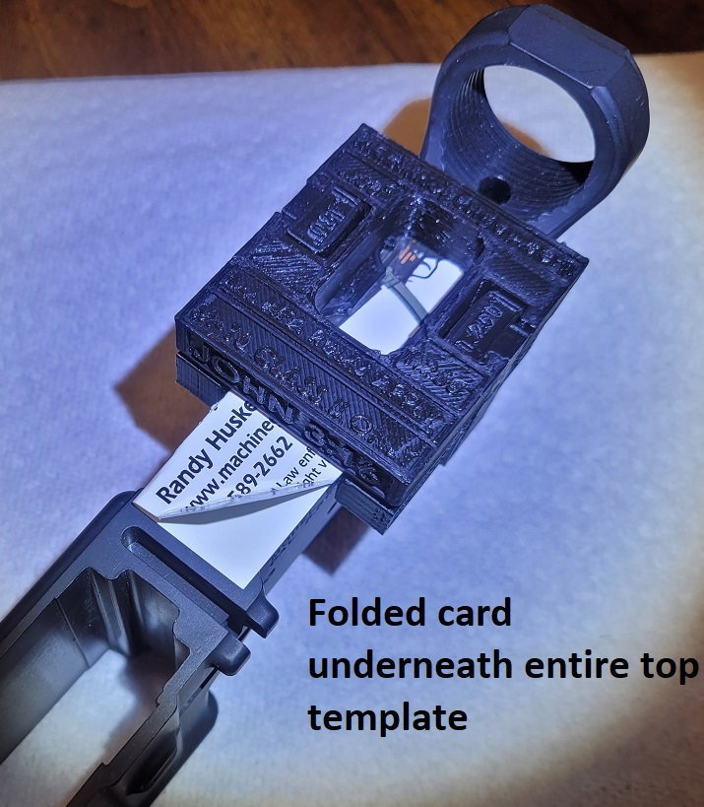

HOWEVER, IF TEETER TOTTER IS STILL AN ISSUE, YOU WILL NEED TO FIND ANOTHER RECEIVER, BECAUSE YOURS HAS BEEN MILLED DOWN TOO FAR BY THE ORIGINAL MANUFACTURER.

As far as overall width of the outer walls in the fire control pocket area, normal width is around .875”.
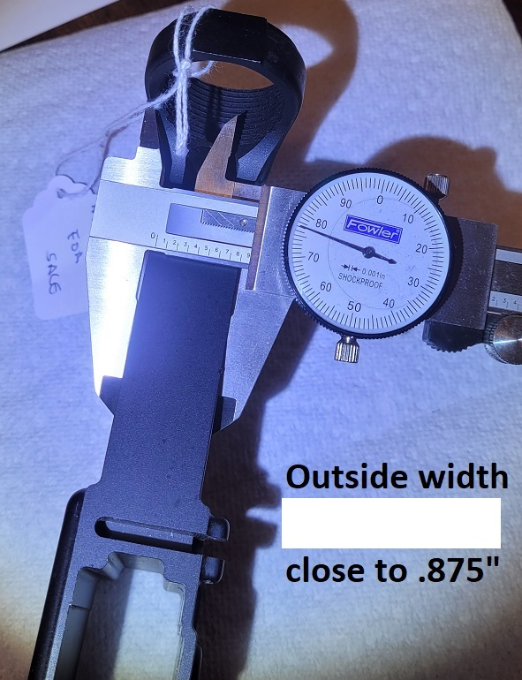

Hopefully this will answer all of your questions.

randy@machinegunguy.com

