Galil autosear modification details

Jig assembled around “cut receiver”
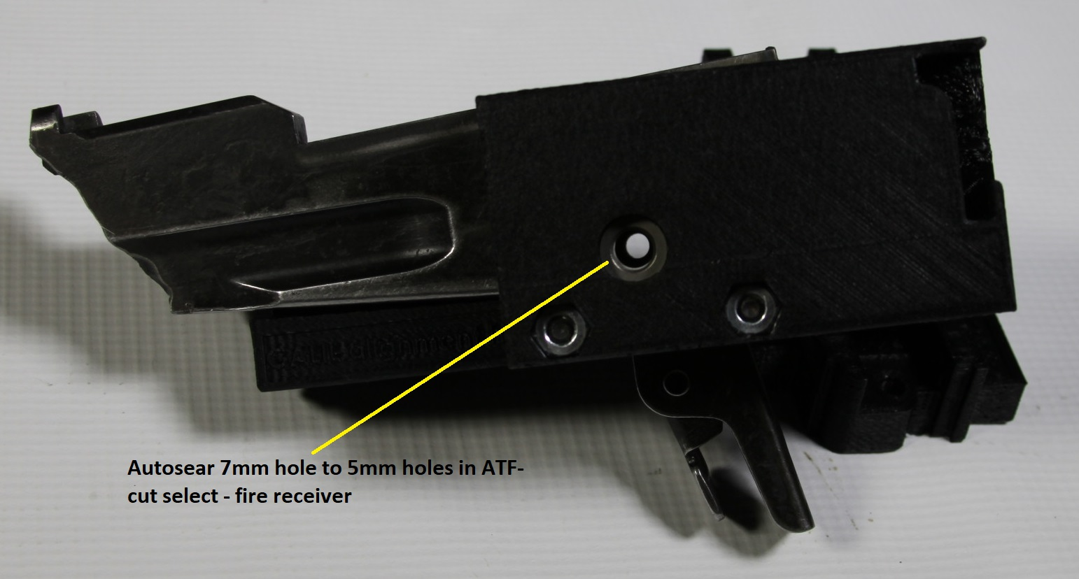

Different use with magazine well autosear slot indicator using crossbolt instead of trigger slot.
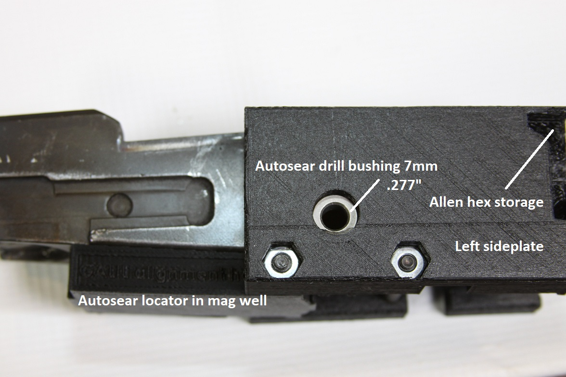
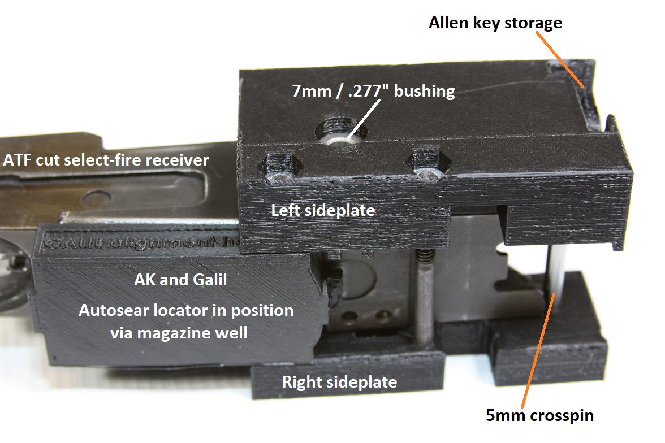

Thunderstruck machinegun rental promotional video

Click on above picture (email address contained therein is old-use the new one)


Click picture above to view photo album

Galil addendum for milling measurements given out after order

